**AKHMATOVA, Anna (АХМАТОВА, АННА) 1889-1966**

Anna Akhmatova is one of Russia’s most famous poets and arguably its most famous woman poet. Her fame is due not only to the exceptional quality of her writing but also to her fascinating biography. During her formative years, she belonged to a literary movement known as Acmeism. The Acmeist poets—who included her first husband Nikolai Gumilev, as well as the great poet Osip Mandelstam—strove to move away from the dominant Symbolist aesthetic and work toward higher clarity and precision. Akhmatova’s early lyric poetry found great success but the Communist years proved very difficult for her. Her famous poems “Poem Without a Hero” (“Poema bez geroia”) and “Requiem” (“Rekviem”) address the oppressive historical period in which she lived.

**Timeline of Life and Works:**

1889: born in Bolshoi Fontan, near Odessa

1890: family moves to Pavlovsk and then to Tsarskoe Selo

1903: meets Nikolai Gumilev

1905: parents separate. Begins writing poetry

1906: attends gymnasium in Kiev. Publishes first poem

1910: marries Gumilev. Spends honeymoon in Paris.

1911: “Tsekh poeta” [“The Poet’s Guild”] is formed

1912: *Vecher* (*Evening*), first book, is published. Son, Lev, is born

1914: *Chetki (Rosary)* is published

1917: separates from Gumilev. *Belaia staia (White Flock)* is published

1918: divorces Gumiliev. Marries Vladimir Shileiko.

1921: leaves Shileiko. Gumilev is executed by Bolsheviks for conspiracy. *Podorozhnik (Plantain)* is published. *Anno Domini MCMXXI* is also published

1926: moves into Fountain House with Punins

1928: officially divorces Shileiko

1935: Lev arrested, then released. Punin arrested, then released. Begins writing “Requiem.”

1938: Lev arrested again, imprisoned for 17 months.

1940: begins “Poem without a Hero.” *From Six Books* is published, then withdrawn from circulation. Has her first heart attack

1945: meeting with Isaiah Berlin

1946: publishes *Selected Poems.* Decree of the Central Committee bans Akhmatova and the author Mikhail Zoshchenko. *Poems 1909-1945* published.

1949: Punin arrested. Lev imprisoned for half a dozen years

1951: has another heart attack

1953: Punin dies in a prison camp

1955: receives dacha in Komarovo

1956: Lev released

1958: *Poems* published

1961: *Poems 1909-1960* published

1965: in England receives an honorary doctorate from Oxford University. *The Flight of Time* published.

1966: Dies near Moscow. Buried in Komorovo

Anna Akhmatova is one of Russia’s most famous poets and arguably its most famous woman poet. Her enduring fame is due not only to her exceptional talent as a writer but also to her fascinating biography. She was born Anna Andreevna Gorenko at Bol’shoi Fontan near Odessa, Ukraine, on June 23 (June 11, Old Style), 1889. Her father, Andrei Gorenko, was a naval engineer; her mother, Inna Stogova, came from a wealthy family. Her parents separated in 1905. Akhmatova spent much of her childhood in Tsarskoe Selo, outside of St. Petersburg. Some of her education took place in Kiev, both at a gymnasium and then for a while as a student in the Law Faculty. She began writing poetry at the age of eleven, and when she published her first poems she did so under her great-grandmother’s Tartar last name, Akhmatova, because her father didn’t approve of her writing poetry.

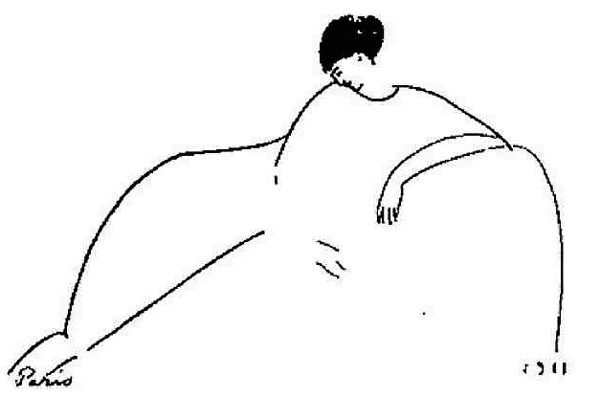Akhmatova was considered to be a great beauty. She was tall and slim, with a distinctive nose, and dark hair worn with bangs. When she was only fifteen years old the young poet Nikolai Gumilev asked her to marry him. She declined his first proposal but married him a few years later, in 1910. They spent their honeymoon in Paris. The following year they returned to Paris, where Akhmatova met the Italian artist Amedeo Modigilani, whose sketches of her are some of her most celebrated portraits. Other famous portraits of her include those by Natan Al’tman (1914) and Yury Annenkov (1921).

Sketch of Akhmatova by Amedeo

Modigliani, 1911.

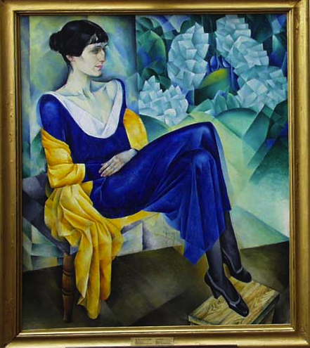

Portrait of Anna Akhmatova by Natan Al’tman, 1914.

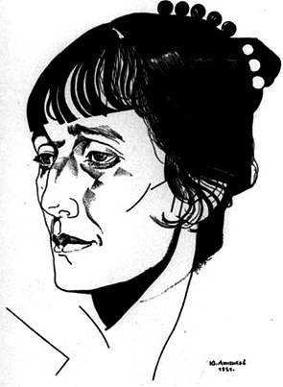During her formative years, she belonged to an organization called *Tsekh poeta* (The Poet’s Guild). This group of Petersburg poets established the important literary movement Acmeism (from the Ancient Greek word *acme,* suggesting a high point or blossoming). Gumilev was the driving force behind the group. The Acmeists, who also included Osip Mandelstam and Sergei Gorodetsky, strove to move away from the mysticism of the dominant Symbolist aesthetic and work toward higher clarity and precision, with a focus on concrete images rather than symbols. They often gathered at the Stray Dog Café, and published most of their manifestos and poetry in the journal *Apollon*. While it was a relatively short-lived group (1911-14), Akhmatova remained faithful to many of the Acmeist principles throughout her life.

Portrait of Akhmatova by Yury

Annenkov, 1921.

Akhmatova’s early lyric poetry (1912-22) is known for its laconicism and psychological depth, its feminine and often prophetic voice, and its focus on love, folklore, and St. Petersburg. Her first book, *Vecher* (*Evening),* was published in 1912 (the same year her only child, Lev, was born). Her second, *Chetki* (*Rosary)* (1914), was the book that established her reputation as a great poet. A slight shift of focus came with her third book, *Belaia staia* (*White Flock)* (1917), as many of the poems now focused on war and loss. The other books that belong to her early period are *Podorozhnik* (*Plantain)* and *Anno Domini MCMXXI*, both published in 1921**.**

In 1918 she divorced Gumilev, who was later executed by the Bolsheviks in 1921. Also in 1918 she married her second husband, the Assyrologist Vladimir Shileiko. The difficulties of this marriage, which lasted about eight years, were reflected in some of Akhmatova’s poetry from the period. After separating from Shileiko, she moved in with the art historian Nikolai Punin, who was already married. Akhmatova, Punin, and his wife all lived together for many years.Punin later died in a prison camp.

Akhmatova’s poetry was viewed by the government as bourgeois and inimical to Soviet concerns. Her nonconformity and popularity with readers led to years of harrowing persecution by Soviet officials. From the mid 1920s to 1940 the Central Committee of the Communist Party placed an unofficial ban on her poetry. Although the authorities never arrested her, they did arrest numerous of her closest relatives and friends. Her son was arrested a number of times in the 1930s, 40s and 50s and served multiple terms in Soviet prisons and labour camps. In 1940, Akhmatova was suddenly allowed to publish — both in journals as well as a full collection of poetry, *Iz shesti knig* (*From Six Books*). The book, however, was withdrawn from circulation soon thereafter. During the war, Akhmatova was evacuated to Central Asia, thus escaping the Nazi siege of Leningrad. During the evacuation she spent a year and a half in Tashkent. Due in part to her Tatar ancestry, Akhmatova felt a deep connection with the place and it became the subject of a number of her later poems. After the war, in 1945, an event occurred which she blamed for her subsequent persecutions: Isaiah Berlin, a renowned scholar and official of the British Embassy, came to meet the famous poet in her Leningrad home. The year after this meeting, the Central committee denounced her and fellow writer Mikhail Zoshchenko.

Her most famous later poems condemn the oppressive historical period in which she lived, while espousing patriotism. Many of her contemporaries emigrated from Russia, but Akhmatova staunchly would not. So there would be no written proof of her heretical poetry, her friends would memorize her poetry as she composed it. The cycle “Rekviem” (“Requiem”) (1935-1940), composed in this way, bears witness to Stalin’s Great Terror and the countless victims of his purges. Another of her most important works is the ambitious and fragmented “Poema bez geroia” (“Poem without a Hero”). It is her longest poem and underwent numerous revisions for over twenty years (1940-62). In addition to writing poetry, Akhmatova also engaged in serious literary criticism (most notably on Aleksandr Pushkin), translation, and autobiographical works.

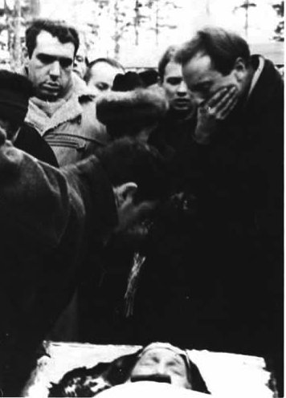After Stalin’s death in 1953, Akhmatova experienced a new freedom. In 1954 she attended the Second Congress of Soviet Writers and the following year she was given a dacha in the writers’ colony near Leningrad in Komarovo. In her final years she mentored a new generation of poets, her ‘orphans,’ who included Joseph Brodsky. She died on March 5th, 1966, of heart failure. It has been said that an entire literary epoch died with her on that day. Her funeral was attended by thousands of people. Akhmatova’s grave rests in Komarovo.

Photograph from Akhmatova’s funeral, 1966.

**References and Further Reading**

**Works by Anna Akhmatova**

**Books of Poetry**

Hemschemeyer, Judith (Trans) and Reeder, Roberta (Ed). *The Complete Poems of Anna Akhmatova.* Bilingual. Two volumes. (1990)

1912: *Vecher* (*Evening*)

1914: *Chetki (Rosary)*

1917: *Belaia staia (White Flock)*

1921: *Podorozhnik (Plantain)*

*Anno Domini MCMXXI*

*1940: Iz shesti knig (From Six Books)*

*1943: Izbrannoe (Selected)*

1946: *Izbrannye stikhi* (*Selected Poems)*

*Stkhotvoreniia (Poems 1909-1945)*

1958: *Stikhotvoreniia* (*Poems)*

1961: *Stikhotvoreniia* (*Poems 1909-1960)*

1965: *Beg vremeni [The Flight of Time]*

**Literary Criticism, Autobiographical writings, Letters**

Meyer, Ronald (trans.) *My Half Century: Selected Prose.* Chicago: Northwestern University Press, 1997.

This volume contains Akhmatova’s major prose works, including: personal letters and diary entries, memoiristic writings, and her literary criticism on Pushkin and Dante.

**Further reading**

Chukovskaya, Lydia. *The Akhmatova Journals: Volume 1* (1938-41) (1994, reissued 2002; originally published in Russian [Paris] in 1974), trans. by Milena Michalski and Sylva Rubashova.

This diary written by Akhmatova’s close friend provides an intimate portrait of the poet, as well as the historical context in which she lived.

Haight, Amanda. *Anna Akhmatova: A Poetic Pilgrimmage*. (1976)

A canonical work. The first English-language biography.

Reeder, Roberta. *Anna Akhmatova: Poet and Prophet*. (1994)

The most comprehensive biography in English of Akhmatova.

**Selection of Critical Works**

Harrington, Alexandra. *The Poetry of Anna Akhmatova: Living in Different Mirrors*. London: Anthem Press, 2006.

Harrington’s scholarly book looks at the formal and thematic differences between Akhmatova’s early and late periods and discusses them in terms of classicism, modernism and postmodernism.

Wells, David. *Anna Akhmatova: Her Poetry*. Oxford: Berg, 1996.

This book is a fine introduction to Akhmatova . All excerpts are provided in translation, as well as in transliterations of the Russian.

**Ona Renner-Fahey, University of Montana-Missoula**

**Photographs**

Here are over 80 photographs of Akhmatova.

<http://www.akhmatova.org/foto/ahm/foto_ahm1.htm>

Source URLs for images:

Figure 1. Modigliani sketch

http://images.google.com/imgres?q=Akhmatova+Modigliani&hl=en&tbm=isch&tbnid=ygdwAWcggzFfFM:&imgrefurl=http://blindflaneur.com/2007/10/27/anna-akhmatova-by-amadeo-modigliani/&docid=3aDMZCSTBEkwHM&imgurl=http://blindflaneur.com/wp-content/uploads/2007/10/akhmatova_modigliani_1911_1.jpg&w=630&h=416&ei=EggHUOH7NcffqAG68onTCA&zoom=1&iact=hc&vpx=128&vpy=166&dur=4070&hovh=182&hovw=276&tx=163&ty=142&sig=112305018103031196608&page=1&tbnh=140&tbnw=212&start=0&ndsp=22&ved=1t:429,r:0,s:0,i:75&biw=1244&bih=691

Figure 2. Portrait by Al’tman.

<http://images.google.com/imgres?q=Akhmatova+altman&hl=en&biw=1233&bih=684&tbm=isch&tbnid=pipleIj8utrwdM:&imgrefurl=http://www.artsstudio.com/reproductions/new_altman.htm&docid=byRnWnSUoyPeyM&imgurl=http://www.artsstudio.com/reproductions/paintings/altm_akhmatova.jpg&w=444&h=500&ei=ZogEUPXJDoikrQHMlICyDA&zoom=1&iact=hc&vpx=841&vpy=320&dur=1730&hovh=238&hovw=212&tx=111&ty=214&sig=104777491517594247560&page=1&tbnh=153&tbnw=116&start=0&ndsp=23&ved=1t:429,r:21,s:0,i:137>

Figure 3. Drawing by Annenkov

<http://images.google.com/imgres?q=Akhmatova+annenkov&hl=en&biw=1233&bih=684&tbm=isch&tbnid=Db-HHLz5El0lBM:&imgrefurl=http://www.all-art.org/art_20th_century/annenkov.html&docid=ZvxTAjFjUy5WsM&imgurl=http://cdn2.all-art.org/art_20th_century/cubism/annenkov/15.jpg&w=300&h=405&ei=kooEULb9I8KnrAHozuSyDA&zoom=1&iact=hc&vpx=242&vpy=98&dur=2956&hovh=261&hovw=193&tx=108&ty=174&sig=104777491517594247560&page=1&tbnh=149&tbnw=110&start=0&ndsp=22&ved=1t:429,r:9,s:0,i:100>

Figure 4. Funeral

<http://www.google.com/imgres?q=Akhmatova%27s+funeral&um=1&hl=en&client=safari&sa=N&rls=en&biw=1233&bih=706&tbm=isch&tbnid=X4dQoaGR2q51GM:&imgrefurl=http://max.mmlc.northwestern.edu/~mdenner/Demo/poetpage/akhmatova.html&docid=-oXGID_Bqw6paM&imgurl=http://max.mmlc.northwestern.edu/~mdenner/Demo/images/akhmatova/ugrobaannybrodskiinapravo.jpg&w=359&h=500&ei=yPwGUOWOH-Ps2QX_36HABQ&zoom=1&iact=hc&vpx=127&vpy=64&dur=7193&hovh=265&hovw=190&tx=103&ty=151&sig=104777491517594247560&page=1&tbnh=172&tbnw=123&start=0&ndsp=19&ved=1t:429,r:0,s:0,i:75>